Санкт-Петербургское государственное бюджетное
профессиональное образовательное учреждение
«Ижорский политехнический колледж»

ОТЧЕТ
дисциплина

Практическое задание № 3
«Объекты и классы»

Студента Турсунова Азамата
группы 331
(подпись, дата)

Руководитель практики
Махов Александр Алексеевич
(оценка, подпись, дата)

Санкт-Петербург
2025

Задание 1
Код:
#include <iostream>
#include <string>
using namespace std;

class ProductBatch {
private:
int quantity;
string name;
int day, month, year;
int sold;
int written_off;

public:
void initialize(int q, string n, int d, int m, int y) {
cout << "Call initialize: " << q << " pcs, " << n << ", date " << d << "." << m << "." << y << endl;
quantity = q;
name = n;
day = d;
month = m;
year = y;
sold = 0;
written_off = 0;
}

void sell(int count = 1) {
cout << "Call sell: selling " << count << " pcs" << endl;
if (count <= getBalance()) {
sold += count;
}
else {
cout << "Not enough product!" << endl;
}
}

void writeOff(int count = 1) {
cout << "Call write off: writing off " << count << " pcs" << endl;
if (count <= getBalance()) {
written_off += count;
}
else {
cout << "Not enough product!" << endl;
}
}

void showBalance() {
cout << "Call Balance" << endl;
int balance = getBalance();
cout << "Product balance '" << name << "': " << balance << " pcs" << endl;
}

void fullReport() {
cout << "Call fullReport\n" << endl;
cout << "-Full batch report-" << endl;
cout << "Product: " << name << endl;
cout << "Delivery date: " << day << "." << month << "." << year << endl;
cout << "Quantity: " << quantity << " pcs" << endl;
cout << "Sold: " << sold << " pcs" << endl;
cout << "Written off: " << written_off << " pcs" << endl;
cout << "Balance: " << getBalance() << " pcs" << endl;

}

int getBalance() {
return quantity - sold - written_off;
}
};

void test1(ProductBatch& batch) {
cout << "\nTEST 1" << endl;
batch.initialize(100, "Apples", 15, 10, 2025);
batch.sell(20);
batch.writeOff(5);
batch.sell(10);
batch.showBalance();
batch.fullReport();
}

void test2(ProductBatch& batch) {
cout << "\nTEST 2" << endl;
batch.initialize(50, "Bananas", 20, 10, 2025);
batch.sell();
batch.writeOff(3);
batch.sell(15);
batch.writeOff();
batch.showBalance();
batch.fullReport();
}

void test3(ProductBatch& batch) {
cout << "\nTEST 3" << endl;
batch.initialize(200, "Oranges", 25, 10, 2025);
batch.sell(50);
batch.writeOff(10);
batch.sell(30);
batch.writeOff(5);
batch.showBalance();
batch.fullReport();
}

int main() {
ProductBatch batch;
int choice;

int q, d, m, y;
string n;

cout << "Enter quantity: ";
cin >> q;
cout << "Enter product name: ";
cin >> n;
cout << "Enter delivery date (day month year): ";
cin >> d >> m >> y;

batch.initialize(q, n, d, m, y);

cout << "\nChoose test (1-3): ";
cin >> choice;

switch (choice) {
case 1: test1(batch); break;
case 2: test2(batch); break;
case 3: test3(batch); break;
default: cout << "Wrong choice" << endl;
}

return 0;
}

Пример вывода:
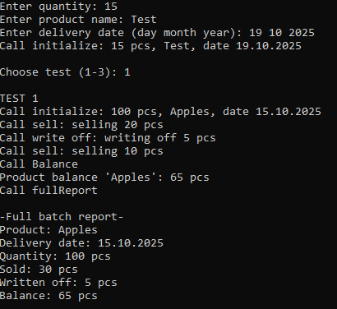
Класс ProductBatch реализует учет партии, также тут методы которые выполняют инициализацию, продажу и списание. Каждый метод выводит сообщение о своем вызове, а тесты демонстрируют работу класса.

Задание 2
Код:
#include <iostream>
#include <string>
using namespace std;

class ProductBatch {
protected:
int quantity;
string name;
int day, month, year;
int sold;
int written_off;

public:
void initialize(int q, string n, int d, int m, int y) {
cout << "Call initialize: " << q << " pcs, " << n << ", date " << d << "." << m << "." << y << endl;
quantity = q;
name = n;
day = d;
month = m;
year = y;
sold = 0;
written_off = 0;
}

void sell(int count = 1) {
cout << "Call sell: selling " << count << " pcs" << endl;
if (count <= getBalance()) {
sold += count;
}
else {
cout << "Not enough product!" << endl;
}
}

void writeOff(int count = 1) {
cout << "Call writeOff: writing off " << count << " pcs" << endl;
if (count <= getBalance()) {
written_off += count;
}
else {
cout << "Not enough product!" << endl;
}
}

void showBalance() {
cout << "Call Balance" << endl;
cout << "Product balance '" << name << "': " << getBalance() << " pcs" << endl;
}

void fullReport() {
cout << "Call fullReport\n" << endl;
cout << "-Full Report-" << endl;
cout << "Product: " << name << endl;
cout << "Delivery date: " << day << "." << month << "." << year << endl;
cout << "Initial: " << quantity << " pcs" << endl;
cout << "Sold: " << sold << " pcs" << endl;
cout << "Written off: " << written_off << " pcs" << endl;
cout << "Balance: " << getBalance() << " pcs" << endl;
}

int getBalance() {
return quantity - sold - written_off;
}
};

class PackagedProduct : public ProductBatch {
private:
int items_per_package;
int total_packages;

public:
void initialize(int packages, int items_per_pack, string n, int d, int m, int y) {
items_per_package = items_per_pack;
total_packages = packages;
quantity = packages * items_per_pack;

cout << "Call initialize: " << packages << " packs of " << items_per_pack << " pcs, " << n << endl;
name = n;
day = d;
month = m;
year = y;
sold = 0;
written_off = 0;
}

void sellPackage(int packages = 1) {
cout << "Call sellPackage: selling " << packages << " packages" << endl;
int items_to_sell = packages * items_per_package;
if (items_to_sell <= getBalance()) {
sold += items_to_sell;
}
else {
cout << "Not enough product to sell " << packages << " packages!" << endl;
}
}

void showBalance() {
cout << "Call Balance" << endl;
int balance = getBalance();
int full_packages = balance / items_per_package;
int remainder = balance % items_per_package;

cout << "Product balance '" << name << "': " << endl;
cout << " Total: " << balance << " pcs" << endl;
cout << " Full packages: " << full_packages << " packs" << endl;
cout << " Separate: " << remainder << " pcs" << endl;
}
};

int main() {
PackagedProduct product;
int choice;

int packages, items_per_pack, d, m, y;
string name;
cout << "Enter number of packages: ";
cin >> packages;
cout << "Enter items per package: ";
cin >> items_per_pack;
cout << "Enter product name: ";
cin >> name;
cout << "Enter delivery date (day month year): ";
cin >> d >> m >> y;

product.initialize(packages, items_per_pack, name, d, m, y);

do {
cout << "\n-MENU-" << endl;
cout << "1 - Sell 1 pc" << endl;
cout << "2 - Sell N pcs" << endl;
cout << "3 - Sell 1 package" << endl;
cout << "4 - Sell N packages" << endl;
cout << "5 - Write off 1 pc" << endl;
cout << "6 - Write off N pcs" << endl;
cout << "7 - Show balance" << endl;
cout << "8 - Full report" << endl;
cout << "0 - Exit" << endl;
cout << "Choose action: ";
cin >> choice;

switch (choice) {
case 1:
product.sell();
break;
case 2: {
int count;
cout << "Enter quantity: ";
cin >> count;
product.sell(count);
break;
}
case 3:
product.sellPackage();
break;
case 4: {
int packages;
cout << "Enter number of packages: ";
cin >> packages;
product.sellPackage(packages);
break;
}
case 5:
product.writeOff();
break;
case 6: {
int count;
cout << "Enter quantity: ";
cin >> count;
product.writeOff(count);
break;
}
case 7:
product.showBalance();
break;
case 8:
product.fullReport();
break;
case 0:
cout << "Exit" << endl;
break;
default:
cout << "Wrong choice" << endl;
}
} while (choice != 0);

return 0;
}
Пример вывода:
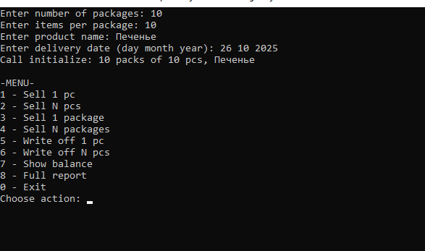
В этом задании расширили класс для работы с упаковками, добавлены новые методы и интерактивное меню.

